**AWS Task-4**

Launch an EC2 instance (Linux and Windows) along with a web server. Then, create an EBS volume of 5 GB, attach it to an EC2 machine (Linux and Windows), and take a snapshot. Finally, create an EBS volume using the taken snapshot.

**\**

**Log in to the AWS Management Console**.Navigate to **EC2** under the "Compute" section.Click **Launch Instance**.Provide the details:**Name**: LinuxInstance.**AMI**: Select Amazon Linux 2 AMI (or any Linux AMI of your choice).**Instance type**: t2.micro (free tier eligible).**Key pair**: Select or create a key pair.**Network settings**: Choose the default VPC and ensure SSH access is allowed (Port 22). **Windows Instance** Repeat the steps for the Linux instance, but select a Windows Server AMI (e.g., Windows Server 2019 Base).Ensure RDP (Port 3389) is allowed in the security group.

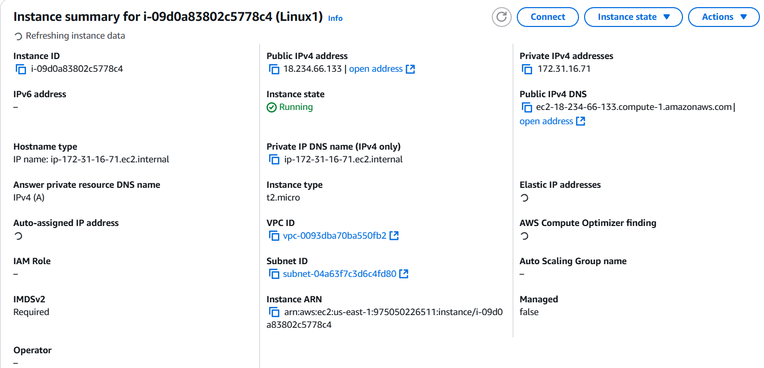

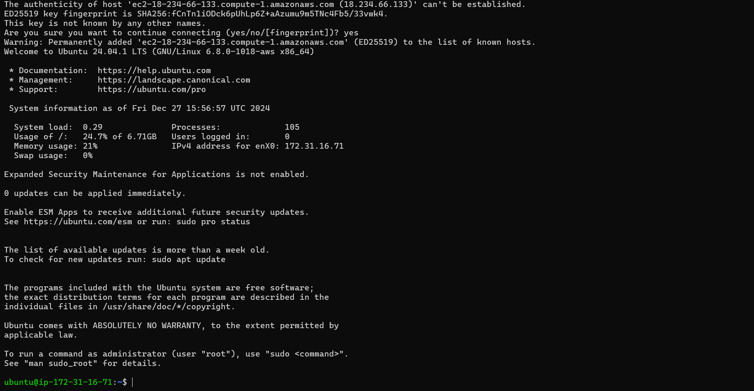

Set Up Web Servers Update the instance and install the web server (e.g., Apache) sudo yum update -y sudo yum install httpd -y sudo systemctl start httpd sudo systemctl enable httpd

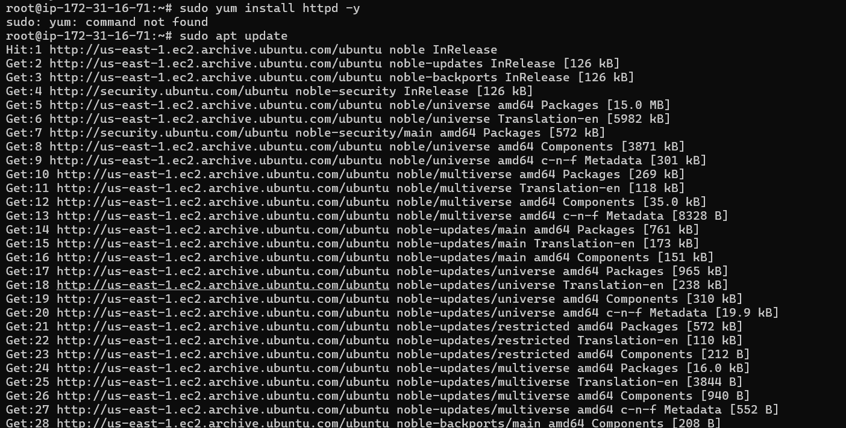

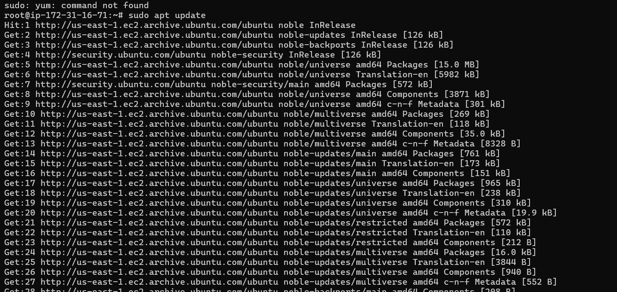

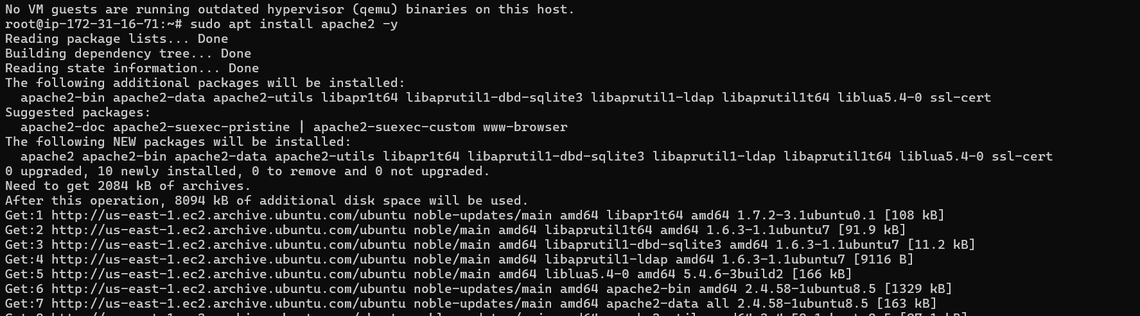





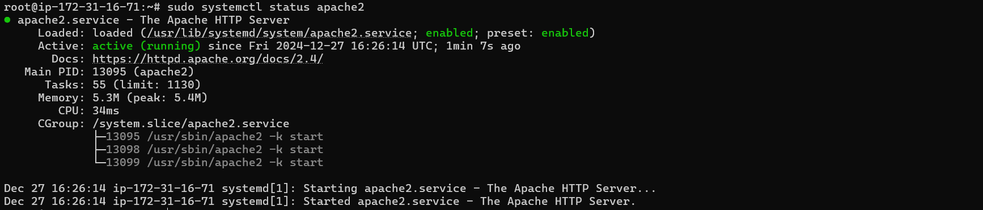

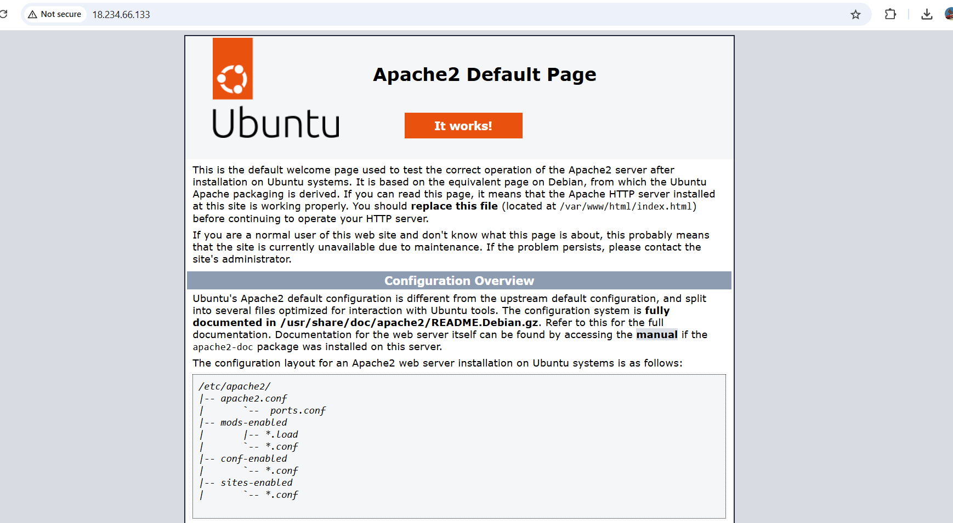

#### ****Windows Instance****

RDP into the Windows instance using the public IP and key.Open **Server Manager**, go to **Manage > Add Roles and Features**.Install the **Web Server (IIS)** role.Once installed, open a browser on your local machine and navigate to the public IP of the instance to see the IIS default page.

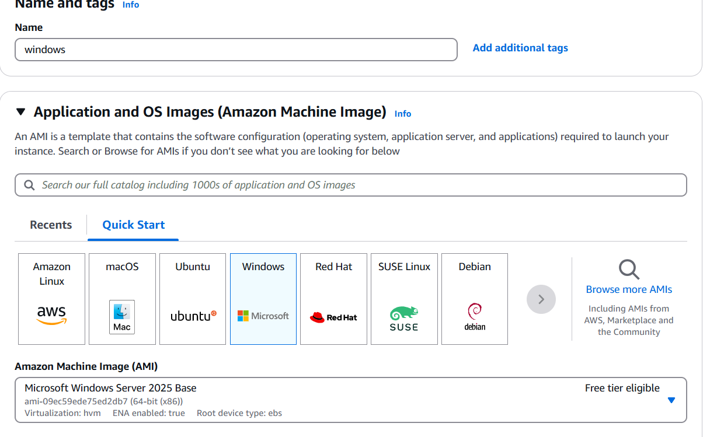

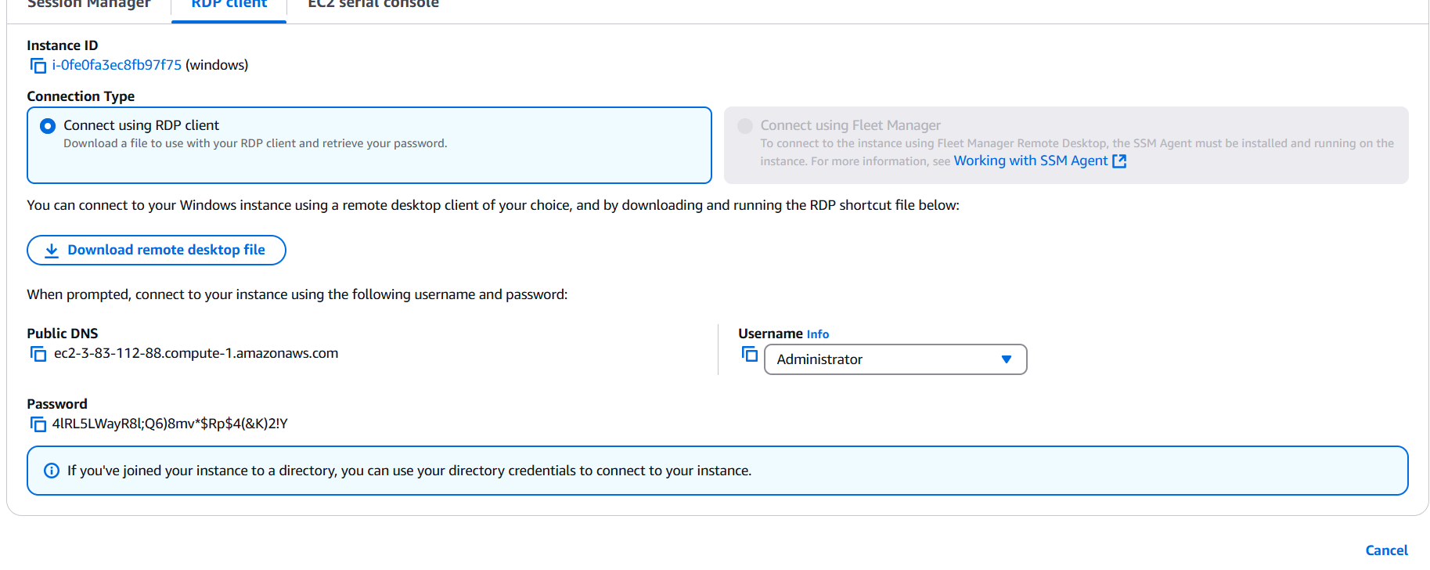

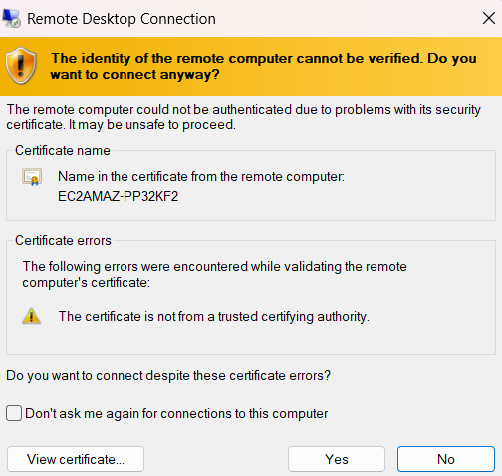

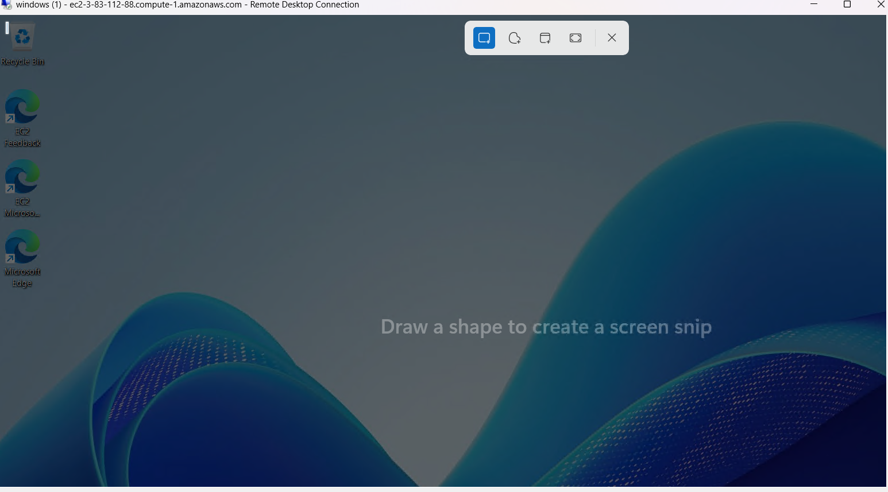

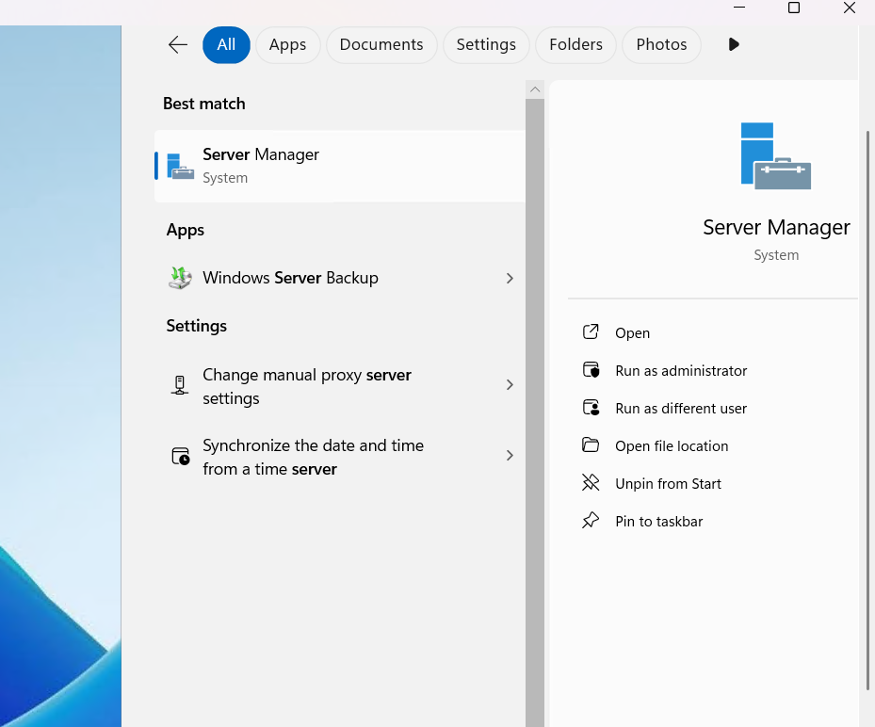

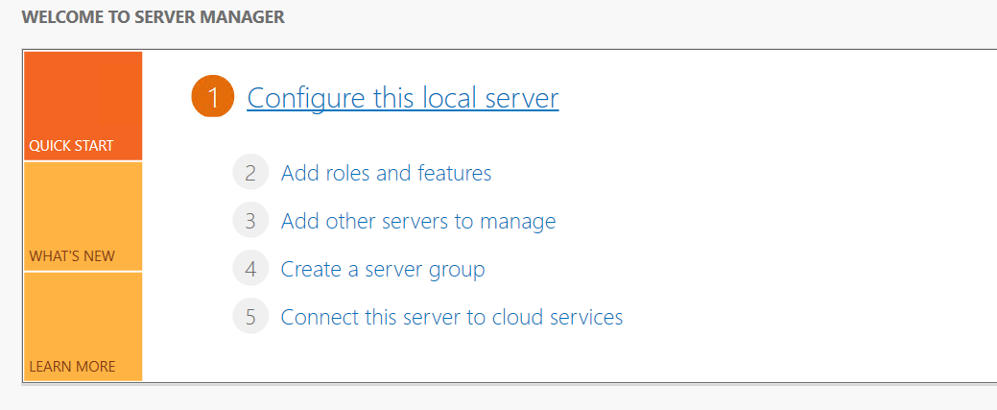

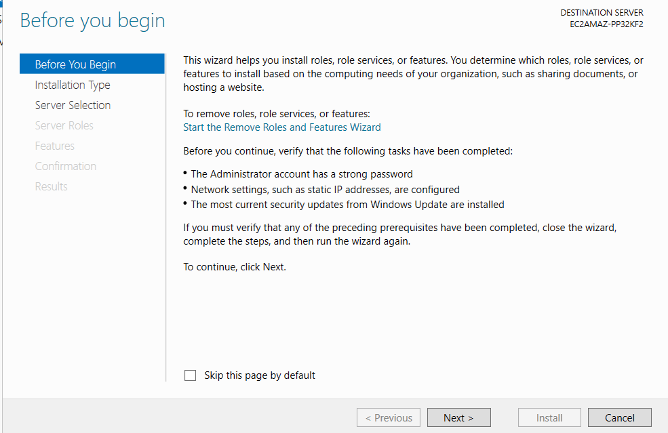

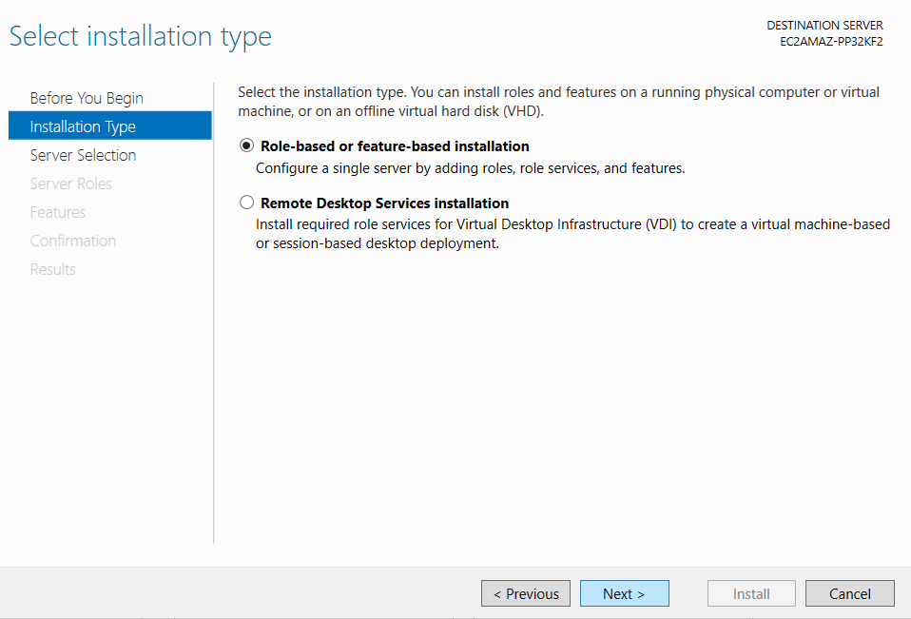

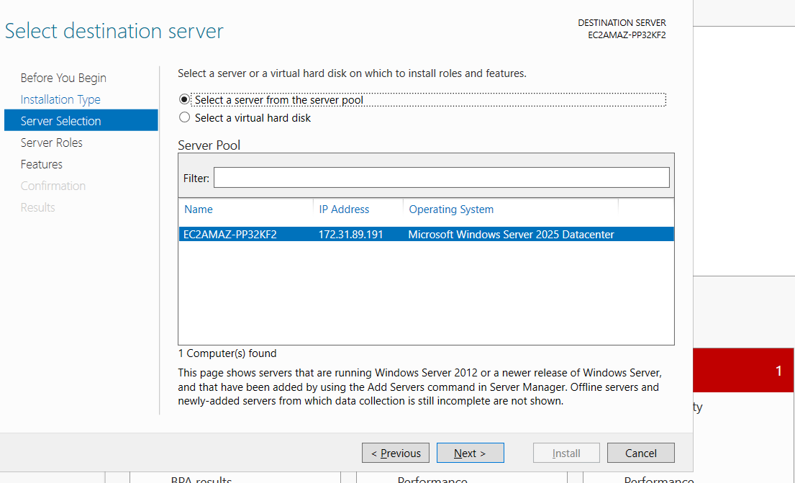

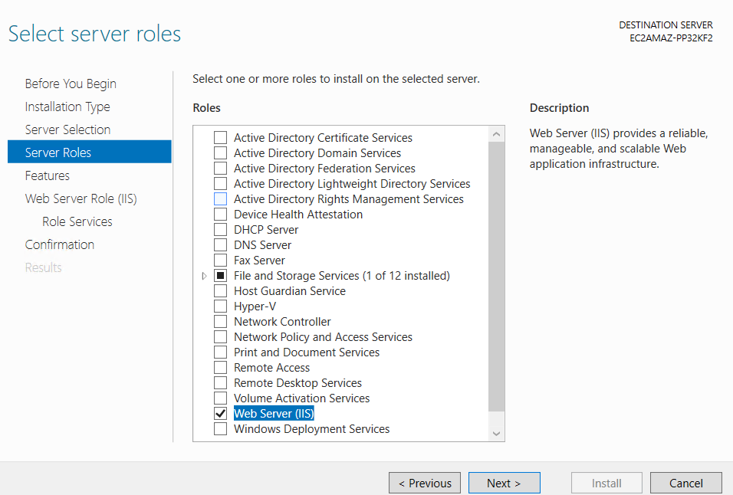

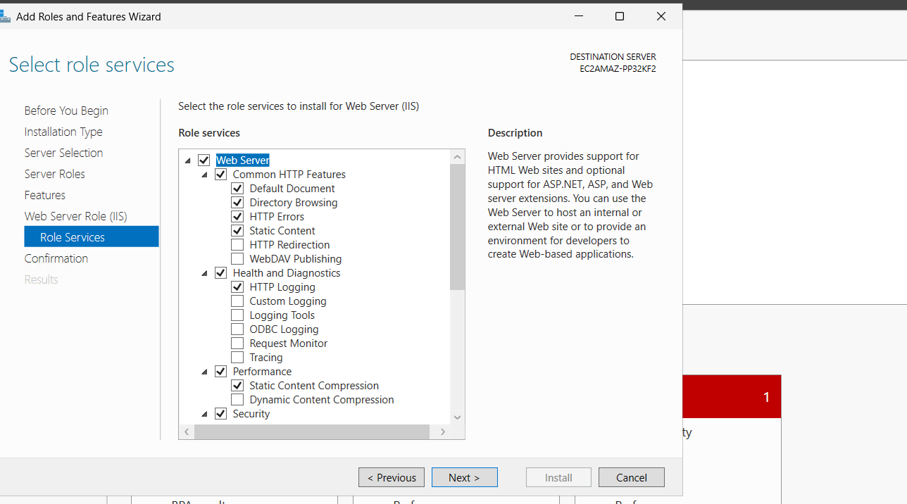

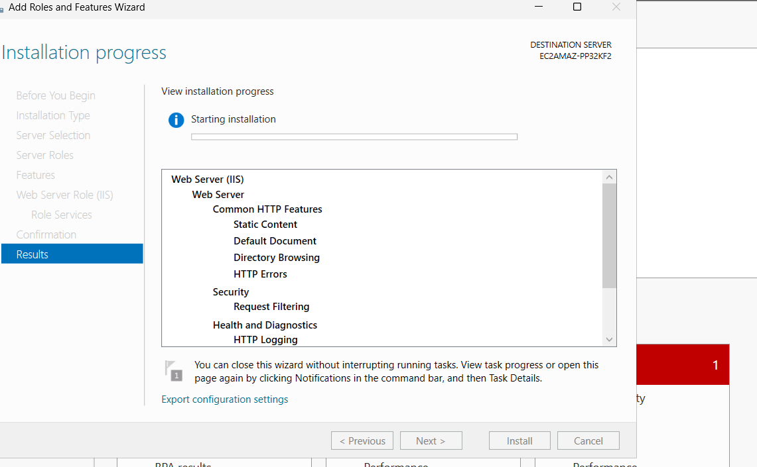

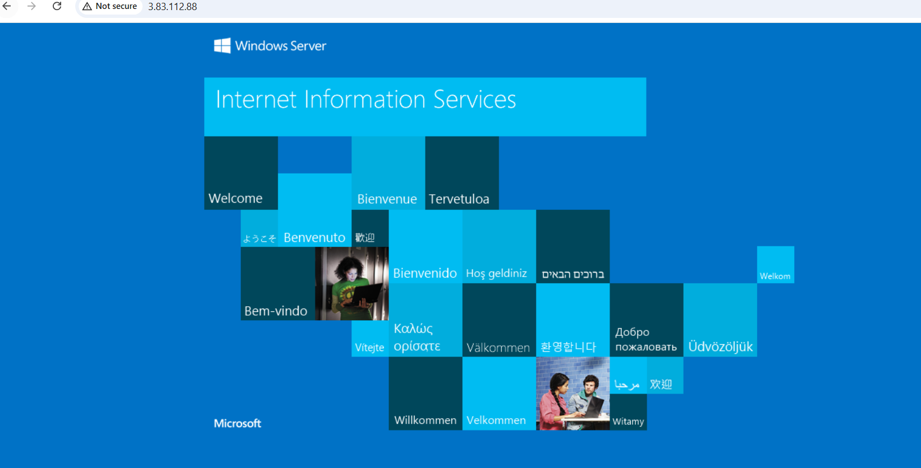

**Create an EBS Volume (5 GB)**Navigate to the **Volumes** section in the EC2 dashboard.Click **Create Volume**:Size: 5 GiB Availability Zone: Select the same AZ as your EC2 instances (e.g., us-east-1a).Click **Create Volume**. Select the newly created volume, click **Actions > Attach Volume**.

Select the Linux instance and attach. SSH into the Linux instance and configure the volume

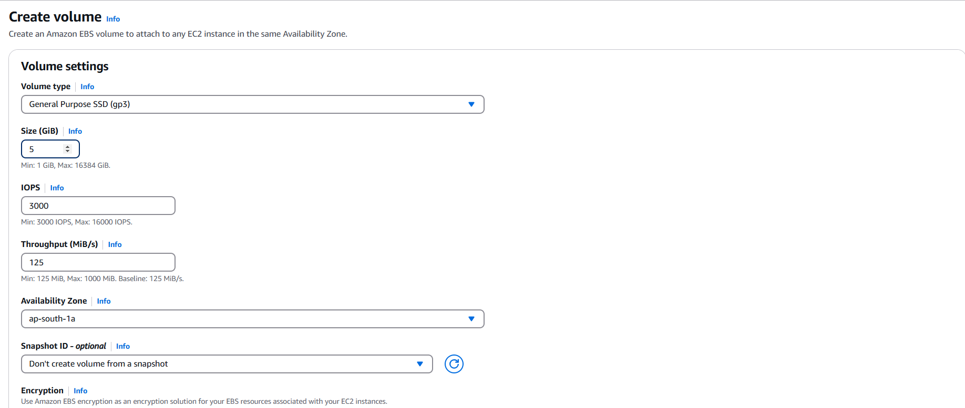

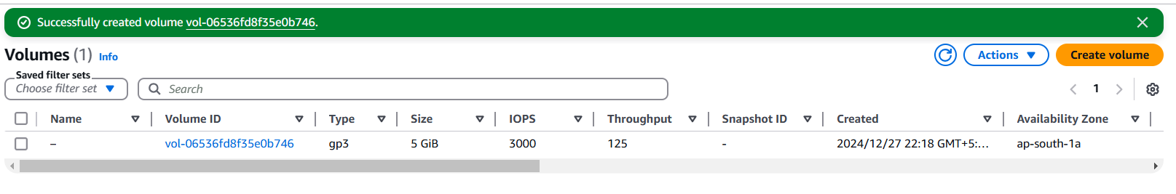

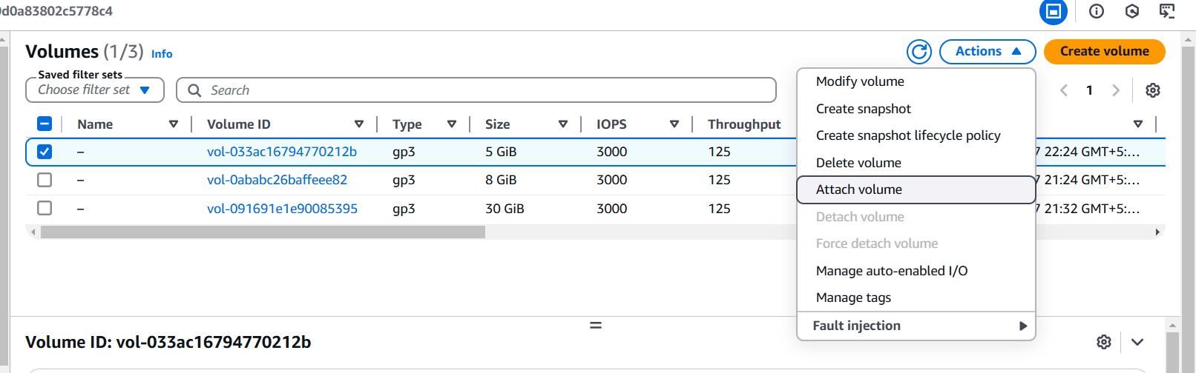

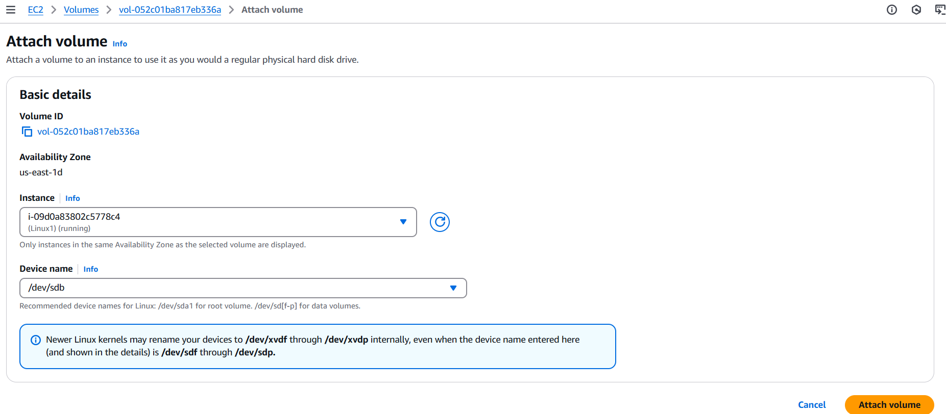

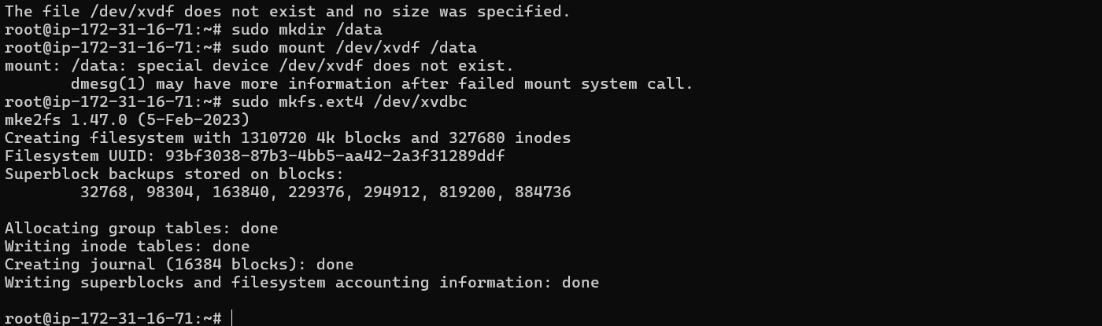

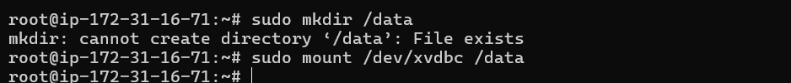





the volume to the Windows instance.RDP into the instance.Open **Disk Management**:Right-click the attached disk, **Initialize Disk**.Create a new volume and assign a drive letter.Format the volume and assign it for use.

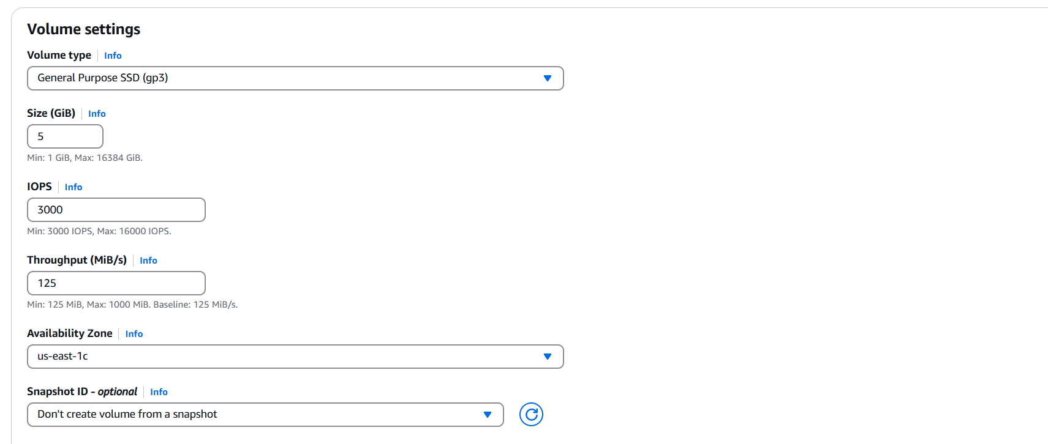

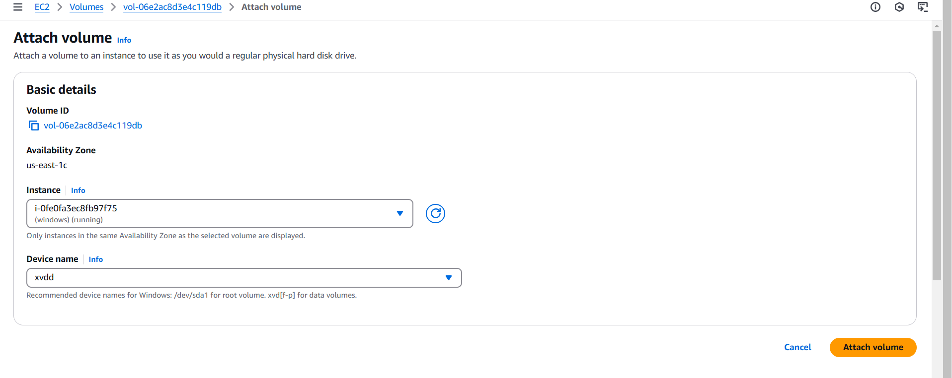

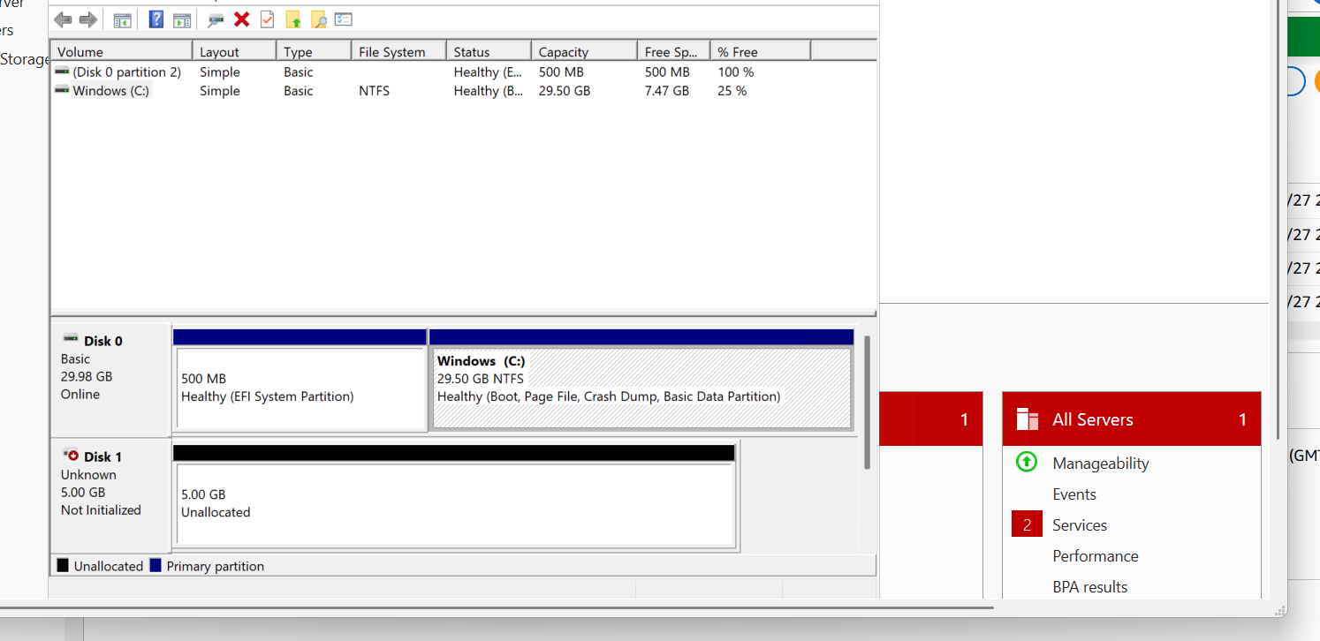

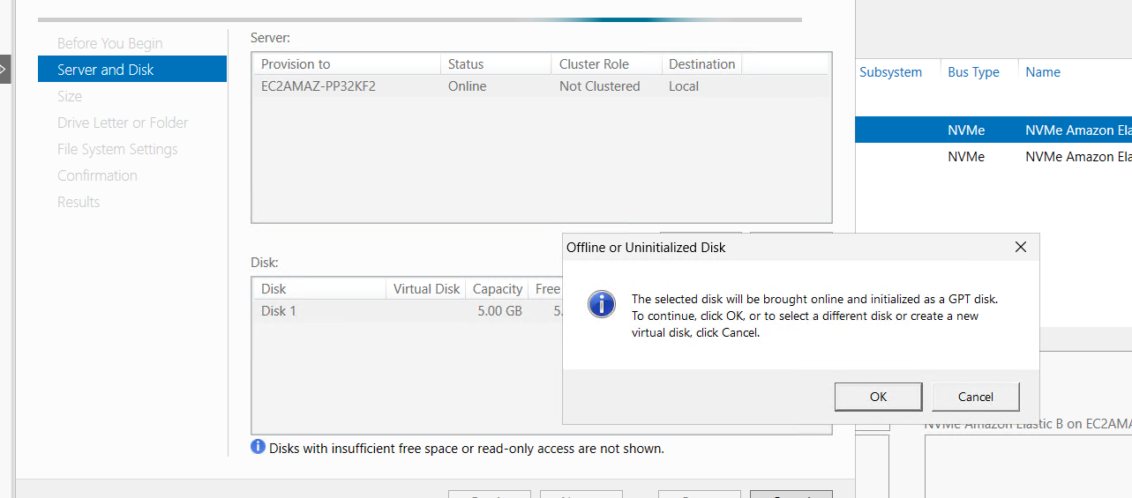

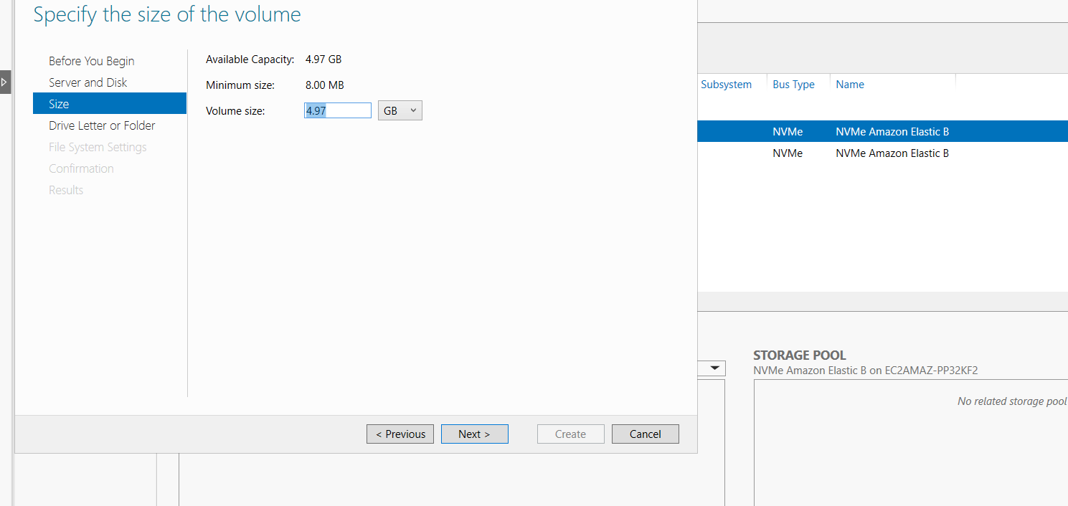

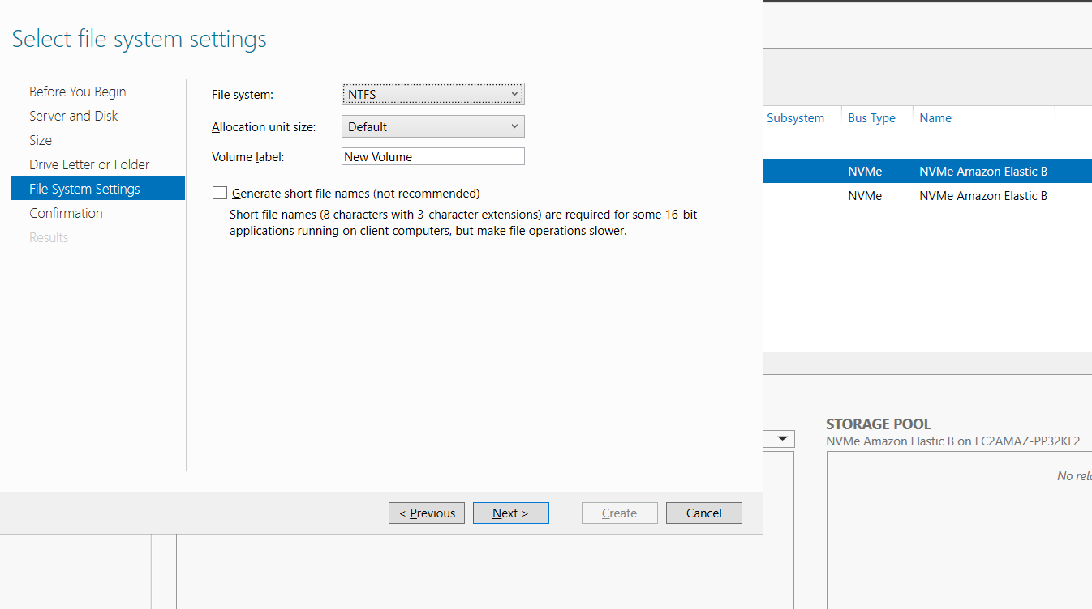

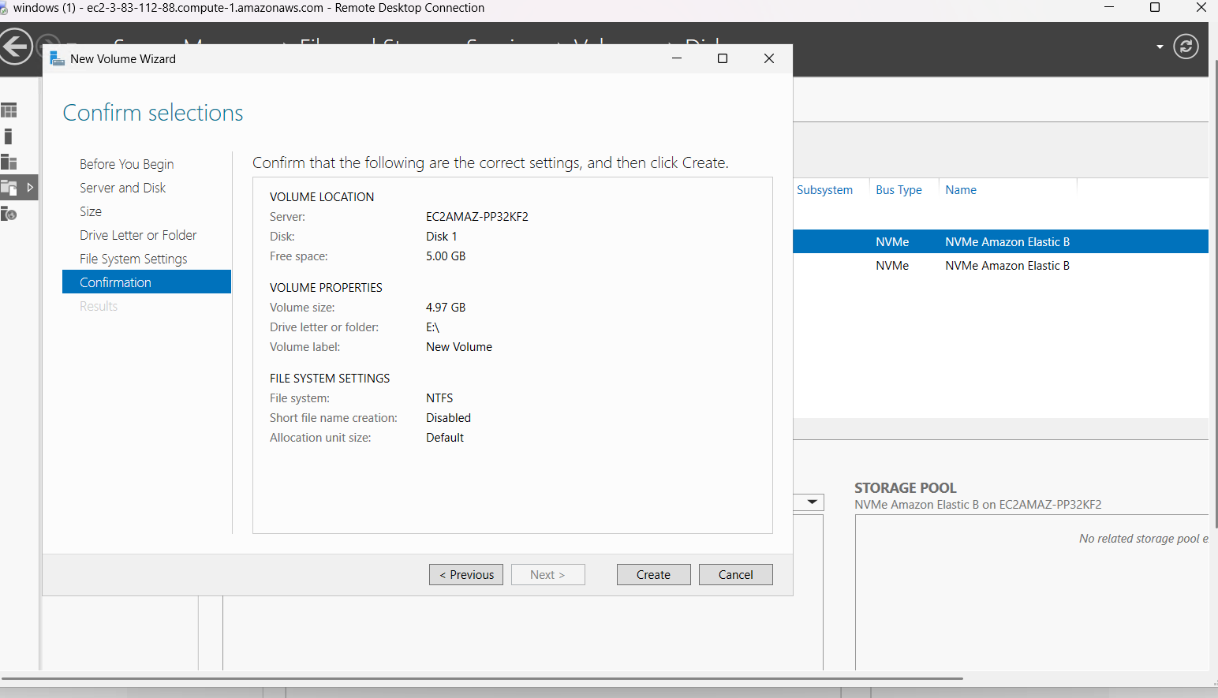

### ****Take a Snapshot of the EBS Volume****

### Go to the ****Volumes**** section, select the volume, and click ****Actions > Create Snapshot****.Provide a name and description for the snapshot.Click ****Create Snapshot****.

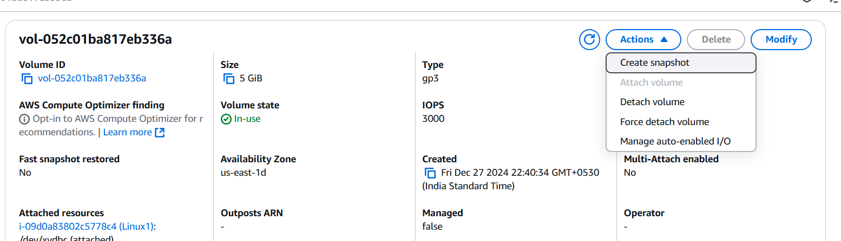

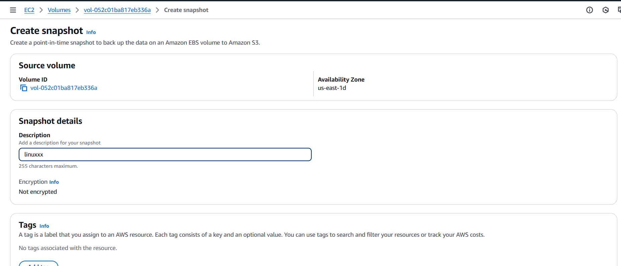

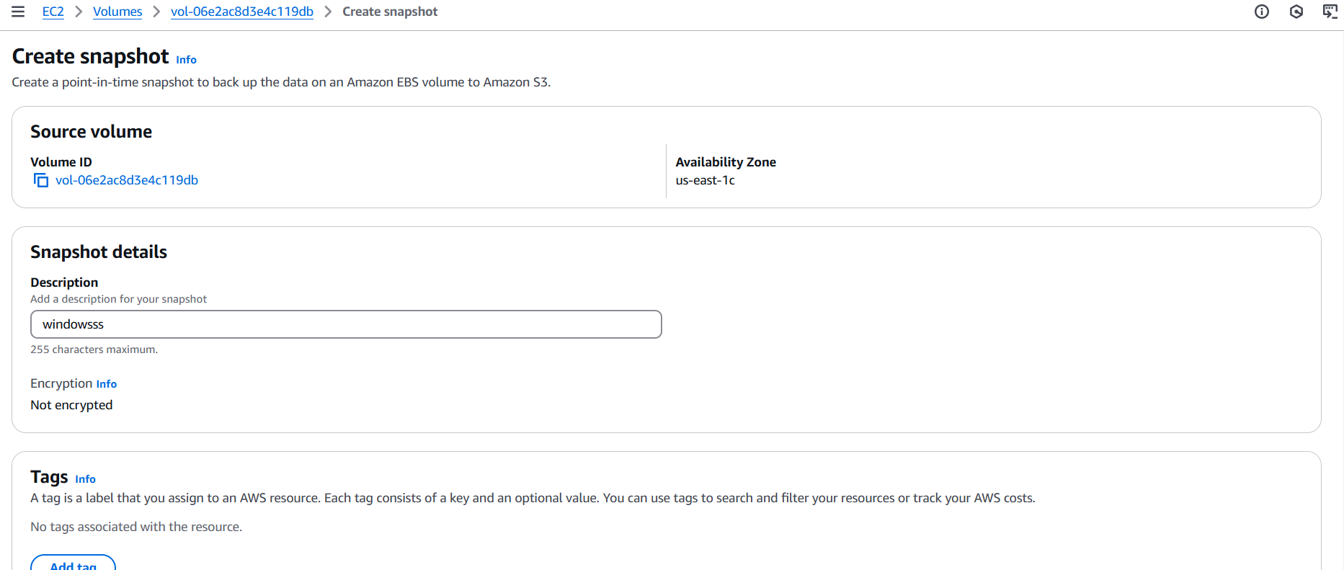

### ****Create a New EBS Volume Using the Snapshot****

Navigate to the **Snapshots** section in the EC2 dashboard.Select the snapshot, click **Actions > Create Volume**.Specify the desired size and AZ (must match the target instance).select the newly created volume, click **Actions > Attach Volume**.select the Linux instance and attach.

